DATA HANDELLING AND VISUALISATION ASSIGNMENT 3
“Analysis of GDP per Capita and Life Expectancy”
Lee Ling Jun 339JIYDY
Abstract –

Introduction

Background & Motivation
Economic development and population health has grown over the last two centuries. Improved economic development tend to result in improved quality of life, contributing to increase longevity. Despite that, there still remains a substantial difference, where some high-income countries still experience modest health outcomes, whilst certain middle-income nations achieve unexpectedly high longevity. This motivates a data-driven exploration of how closely economic prosperity and life expectancy move together.

Research Question & Objectives
The overarching motivation of this whole project stands as: How does GDP per capita relate to life expectancy across countries and over time?
The line of enquiry that guides this analysis:
- Describe long-run global trends in both GDP per capita and life expectancy.
- Examine the cross-sectional relationship in recent years, including whether log-transforming GDP clarifies the association.
- Compare outcomes across income groups and identify countries that perform better or worse than expected given their income level.

Scope of the Analysis
The analysis combines life expectancy at birth with GDP per capita from the Maddison Project using annual country-level data from 1800 to 2020. Focussing on GDP as the main economic indicator, the descriptive and exploratory study aims to visualise patterns and relationships rather than infer causality.

Dataset Overview

Dataset Source & Accessiblities
Two publicly available time-series datasets at the national level—one on economic output and the other on life expectancy—are combined in this project.
- GDP per Capita Data: The Maddison Project Database, which has estimates of GDP per capita in constant international dollars over several centuries, The dataset can be downloaded by the general public through Our World in Data at: https://ourworldindata.org/grapher/gdp-per-capita-maddison-project-database
- Life expectancy data: are drawn from an Our World in Data dataset containing period life expectancy estimates at multiple ages (0, 10, 15, 25, 45, 65 and 80) by country and year. https://ourworldindata.org/grapher/life-expectancy-hmd-unwpp?country=FRA~ZAF~NGA~CHN
Both sources are distributed under open licences that permit academic use, downloading and local processing. The datasets were downloaded as CSV files and stored in the project’s data/raw directory, then merged and cleaned in Python before analysis.

Key Variables and Structure

Data Format
GDP per Capita
Feature | Description
Year | Calendar year of measurement. Dataset is annual time-series.
Entity | Country or region name (e.g. Afghanistan, Spain, United Kingdom).
Code | ISO-3 country code used to uniquely identify each Entity.
Year | Calendar year of measurement. Dataset is annual time-series.
GDP per capita | Gross Domestic Product per person, measured in constant international dollars. This represents economic output adjusted for population size and inflation, making it comparable across countries and over time.
900793-annotations | Auxiliary metadata column (mostly empty). Contains annotation flags used internally by the source organisation. Not used for modelling or analysis.
Figure 1. Features in GDP per capita dataset
The GDP per capita dataset contains annual country-level economic output figures expressed per capita, allowing comparisons across countries independent of total population size. The values are inflation-adjusted (constant international dollars), enabling meaningful comparisons over time. Apart from the main variable, the dataset also includes a mostly empty annotation column, which can be ignored for analysis purposes.

Life expectancy
Feature | Description
Entity | Country or region name (e.g. Afghanistan)
Code | ISO-3 country code
Year | Calendar year of observation
Life expectancy variables (7 columns) | Period life expectancy measures at ages 0, 10, 15, 25, 45, 65, 80 — expected remaining years of life at each age, averaged across sexes
Figure 2. Features in Life expectancy dataset
The Life Expectancy dataset is organised at the country–year level, identified by Entity (country name), Code (ISO-3 code), and Year. The main information is provided through seven life-expectancy variables, which report period life expectancy at ages 0, 10, 15, 25, 45, 65 and 80. Each value represents the expected remaining number of years a person would live if they are currently at that age, based on the mortality rates of that specific year, and averaged across sexes data Preprocessing

Exploratory Data Overview

Descriptive Statistics
GDP Per Capita
 |  |  |  |  | Interquartile range (IQR)
Feature | Count | Mean | σ | Min | 25% | 50% | 75% | Max
Year | 21,586 | 1,885.58 | 173.42 | 1 | 1,865.00 | 1,957.00 | 1,991.00 | 2,022.00
GDP per capita | 21,586 | 6,869.64 | 10,723.73 | 295 | 1,470.00 | 2,617.94 | 7,231.69 | 160,051.23

Figure 3. Descriptive statistic of raw data set in GDP per capita dataset
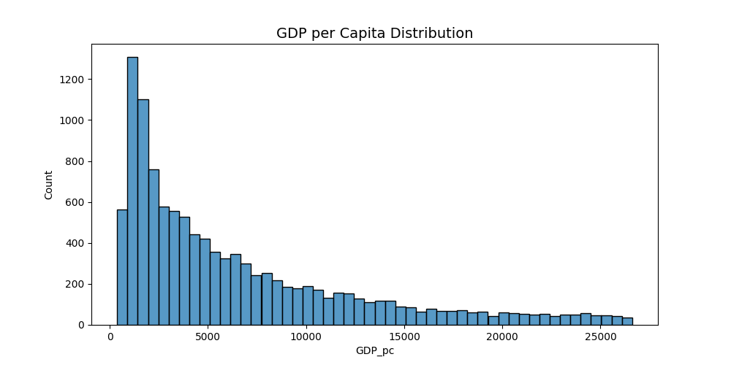
Figure 4. Histogram of raw data set in GDP per capita dataset
The descriptive statistics reveal substantial variation across both datasets. In GDP per capita, having ranges from a few hundred dollars to over USD 160,000, confirming a highly skewed global income distribution with large gaps between low- and high-income countries. Which is further emphasised from the histogram in figure 4.
Life Expectancy
 |  |  |  |  | Interquartile range (IQR)
Feature | Count | Mean | σ | Min | 25% | 50% | 75% | Max
Year | 20,804 | 1980.03 | 32.95 | 1751 | 1964 | 1984 | 2004 | 2023
Life expectancy – Age 0 | 20,804 | 62.74 | 12.32 | 10.99 | 54.18 | 65.19 | 72.23 | 86.37
Life expectancy – Age 10 | 20,804 | 59.04 | 7.08 | 10.23 | 53.93 | 59.69 | 64.05 | 76.80
Life expectancy – Age 15 | 20,804 | 54.43 | 6.75 | 6.93 | 49.54 | 54.94 | 59.17 | 71.82
Life expectancy – Age 25 | 20,804 | 45.66 | 5.91 | 4.73 | 41.33 | 45.86 | 49.71 | 61.91
Life expectancy – Age 45 | 20,804 | 28.68 | 4.10 | 3.60 | 25.66 | 28.30 | 31.22 | 42.16
Life expectancy – Age 65 | 20,804 | 13.82 | 2.54 | 3.01 | 11.96 | 13.32 | 15.21 | 23.21
Life expectancy – Age 80 | 20,804 | 6.11 | 1.30 | 2.05 | 5.21 | 5.81 | 6.74 | 11.82
Figure 5. Descriptive statistic of raw data set in GDP per capita dataset
Similarly, Life expectancy at birth also displays wide dispersion—from around 11 years (10.99) in the poorest historical contexts to over 86 years (86.37) in the most developed.

Missing Data
GDP per Capita
Features | Missingness (%)
900793-annotations | 99.87
Code | 1.26
Entity | 0
Year | 0
GDP per Capita | 0
Figure 6. Missingness of GDP per capita dataset
Life Expectancy
Features | Missingness (%)
Code | 9.3
Entity | 0.0
Year | 0.0
Life expectancy - Sex: total - Age: 0 - Type: period | 0.0
Life expectancy - Sex: total - Age: 10 - Type: period | 0.0
Life expectancy - Sex: total - Age: 15 - Type: period | 0.0
Life expectancy - Sex: total - Age: 25 - Type: period | 0.0
Life expectancy - Sex: total - Age: 45 - Type: period | 0.0
Life expectancy - Sex: total - Age: 65 - Type: period | 0.0
Life expectancy - Sex: total - Age: 80 - Type: period | 0.0
Figure 7. Missingness of Life Expectancy Dataset
The missingness analysis shows that both datasets are exceptionally complete for all key analytical variables. In the GDP dataset, Entity, Year and GDP per capita have 0% missingness, and only the Code field is partially missing (≈1.3%). The annotations column is missing for almost all rows (≈99.9%) but contains only metadata and is discarded. In the life expectancy dataset, all age-specific life expectancy variables (0, 10, 15, 25, 45, 65 and 80) have 0% missingness, with only the Code variable showing modest gaps (≈9.3%). Because Entity uniquely identifies countries, these missing codes do not hinder merging or analysis.

Data Quality
Overall, the merged dataset is strong and highly suitable for analysis. The key analytical features—GDP per capita, life expectancy at birth, and all age-specific life expectancy measures—are fully populated with no missing data, core identifiers like entity and years are fully complete as well.
Structurally, the data is internally consistent, with aligned country names, year ranges, and plausible numerical values. However, as with most long-run cross-country datasets, the underlying GDP and life-table estimates may carry measurement uncertainty—particularly for earlier periods or lower-income regions. Thus, results should be interpreted as reflecting broad patterns rather than exact point estimates.

Pre-processing

Merging data sets
To ensure consistency, an inner join was performed on Entity, Code, and Year. This approach preserves only country–year combinations present in both datasets, avoiding artificial gaps and producing a coherent panel in which each row contains GDP per capita alongside multiple life expectancy measures for the same observation.

Cleaning and Transformation of variables
After merging, several cleaning steps were applied to standardise and simplify the structure of the dataset. Long, descriptive column names for the life expectancy variables (for example, “Life expectancy – Sex: total – Age: 0 – Type: period”) were shortened to concise labels such as LE_0, LE_10, …, LE_80, and GDP per capita was renamed to GDP_pc. This makes subsequent coding and interpretation more manageable while preserving the original meaning. Data types were also harmonised: Year was cast to integer, and all numeric columns were explicitly converted to numeric types with invalid entries coerced to missing. Non-essential metadata columns, such as annotation fields, were dropped to keep only variables that are directly relevant for analysis and visualisation.

Handling Missing values and outliers
Although the key data features are complete, there are a minute number of gaps that were addressed. Variables that were found to have no analytical value were removed (i.e. Life expectancy columns and GDP_pc).
Gaps in within each respective country were imputed through forward and backward fills as to preserve national trends.
Outliers were filtered through the interquartile range (IQR) to ensure distortion of the dataset is kept to a minimum.

Engineered Features
In addition to the raw variables, certain features in the final dataset were constructed.
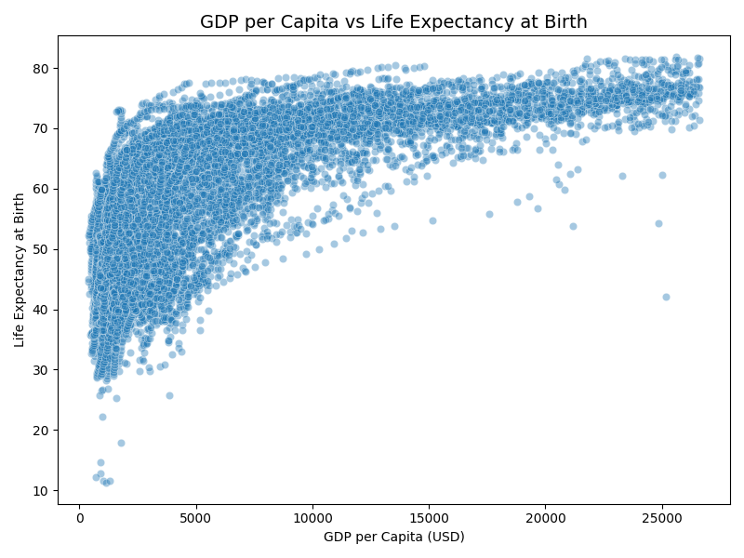
Figure 8. GDP per Capita vs Life Expectancy from birth scatter plot
A logarithmic like curve was noticed during early exploration as shown in Figure 7 the data set. Hence a Logarithmic transformation was done on the GDP per capita value.
A Z-score Standardisation and min-max normalisation was done on the key features (e.g. GDP_pc_z, LE_0_z, GDP_pc_norm, LE_0_norm) to have the comparison of the values to be done a common scale allowing for techniques that are more sensitive to varying magnitudes
These engineered features do not change the underlying information but provide alternative representations that make statistical relationships clearer and simplify the interpretation of model coefficients and visual patterns.

Visual Analysis And Findings

Trends Income and Longevity
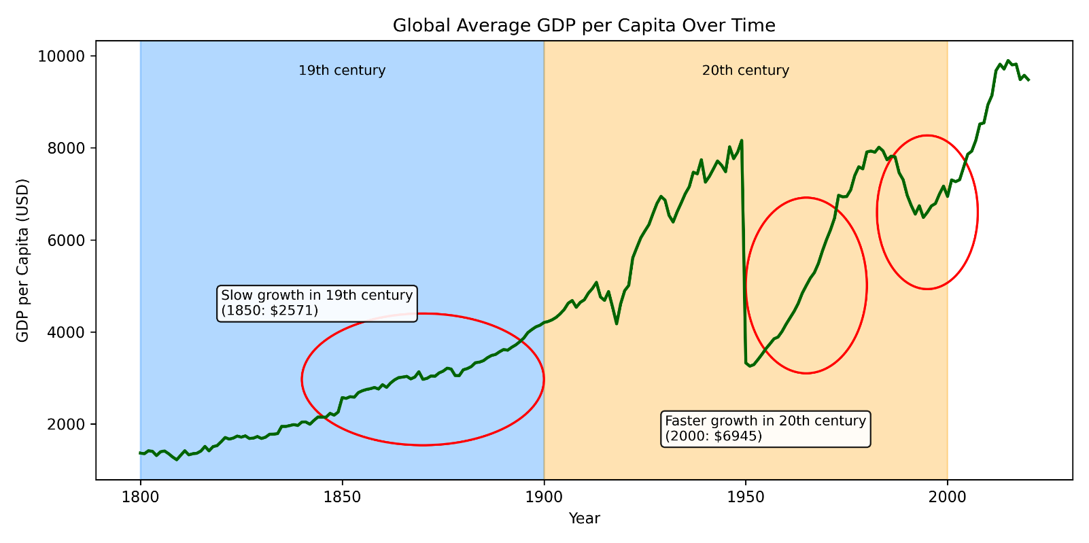
Figure 9. Time series trend of GDP per Capita
The long-run trends in global development exemplified a clear pattern. GDP per capita and life expectancy at birth have risen and moved in a similar way across the years.
In the nineteenth century, global GDP had a v gradual climb. The change in development shifted dramatically in the twentieth century, increasing it up to a global GDP per capita to nearly USD 10,000.
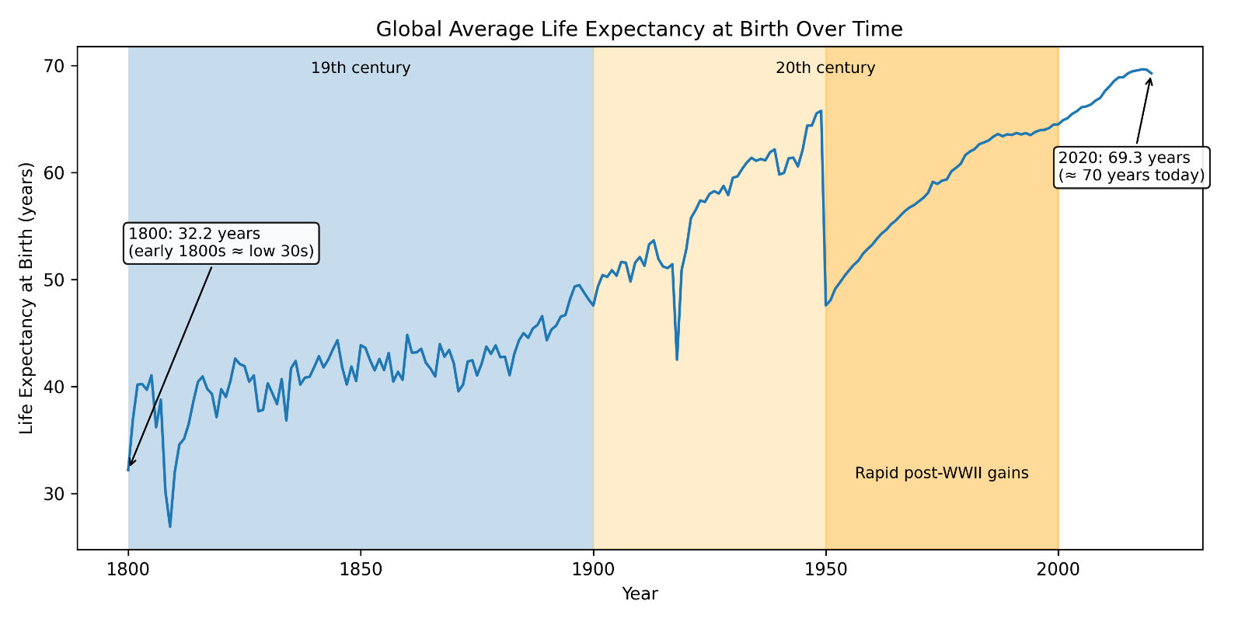
Figure 10. Time series trend of Life Expectancy from birth (LE-0)
A similar pattern in life expectancy. From early 1800s, average life is around 30 years, a gradual increase until the nineteenth century. The large jump occurred after the mid-twentieth century. By 2020, global life expectancy reaches around 70 years—more than double its level two centuries earlier. These paired trajectories demonstrate how economic and health outcomes have moved together over time.

Cross-Sectional Relationship Between GDP and Life Expectancy
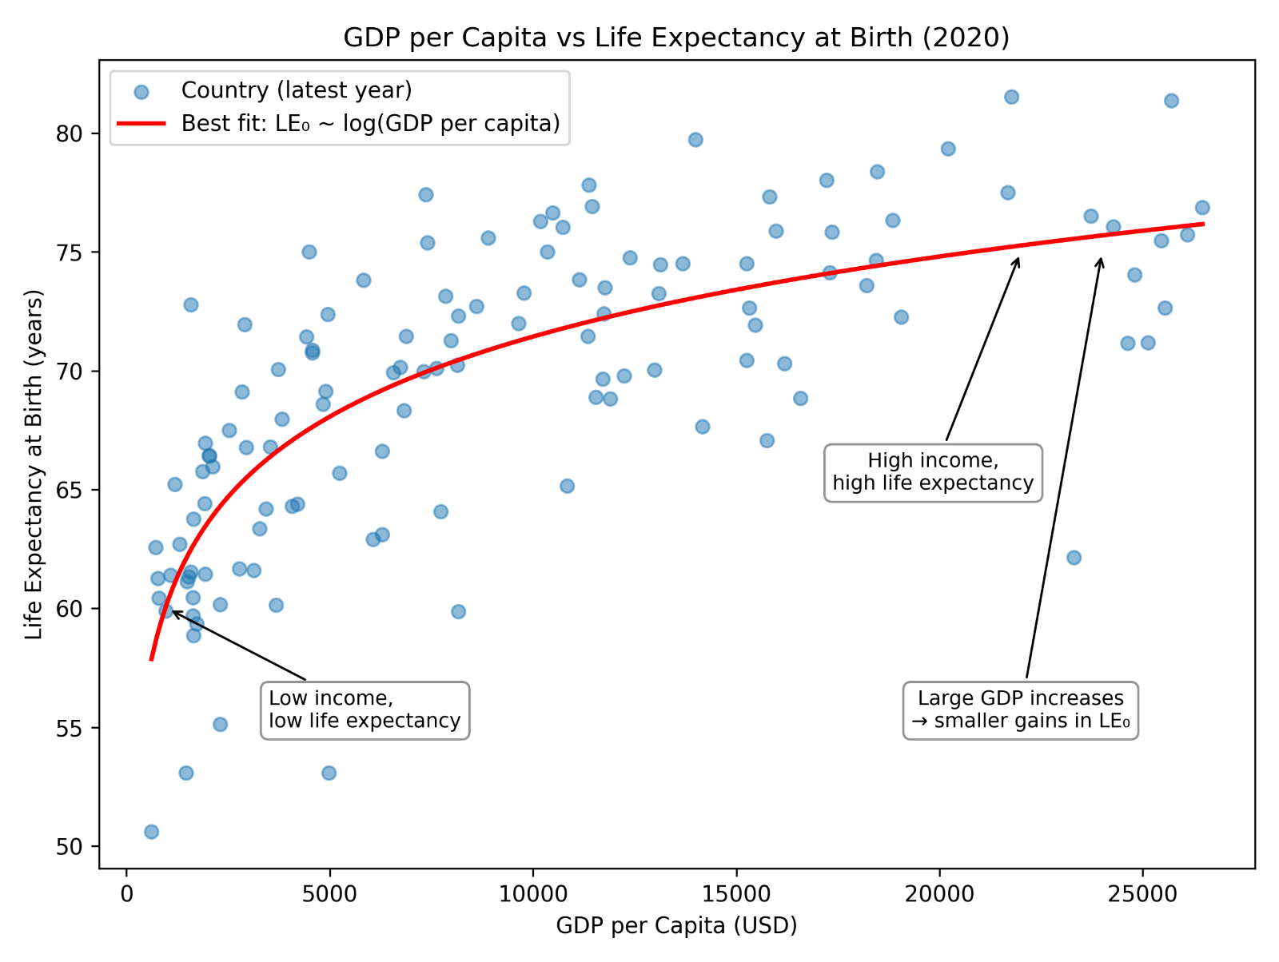
Figure 11. GDP per Capita vs Life Expectancy at Birth (2020).
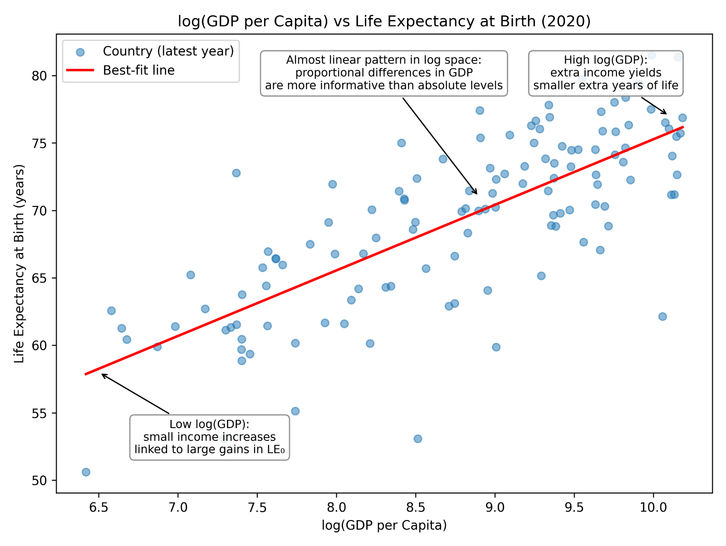
Figure 12. log (GDP per Capita) vs Life Expectancy at Birth (2020).
This relationship becomes clearer in the cross-sectional scatter plots. Countries with low GDP per capita overwhelmingly occupy the bottom-left region of the graph, combining low income with low life expectancy. Vice versa a higher GDP per capita tend to have a higher life expectancy from birth.

Life Expectancy Differences Across Income Groups
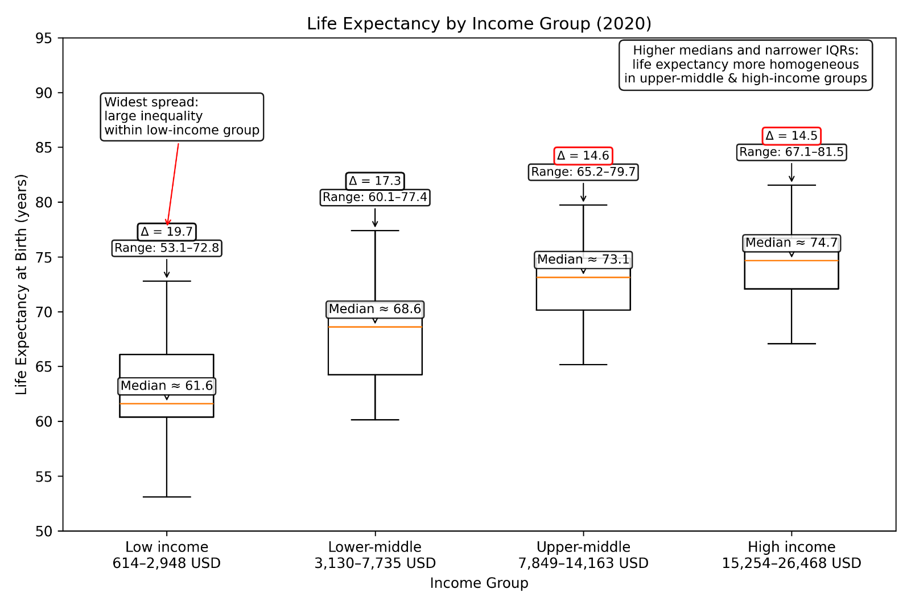
Figure 13. Life expectancy distributions across World Bank income groups (2020).
The boxplot of life expectancy across World Bank income groups further reinforces this gradient.
Low-income countries not only have the lowest median life expectancy (about 61.6 years) but also the largest internal inequality, with a wide spread from roughly 53 to 73 years. As income rises, both the median and the tightness of the distribution improve. Upper-middle- and high-income countries converge toward medians of 73–75 years with narrower spreads, indicating that once basic development thresholds are crossed, life expectancy becomes both higher and more homogeneous
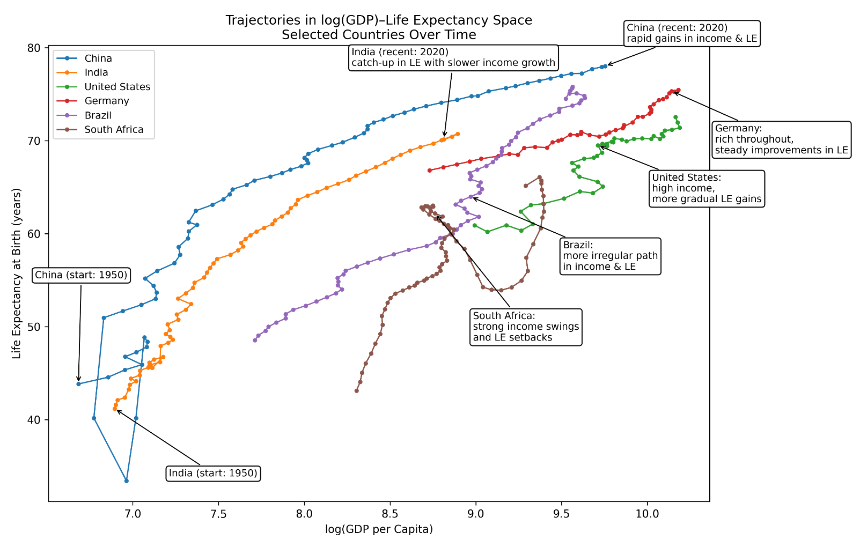
Figure 14. Trajectories of selected countries in log-GDP–life-expectancy space from circa 1950–2020
Country trajectories across time provide a dynamic counterpart to these patterns. China and India show rapid upward-rightward movements as economic growth accompanies major gains in health. Higher-income countries such as Germany and the United States improve more gradually, while Brazil and South Africa reveal uneven progress. These varied paths illustrate that although the long-run link between income and longevity is positive, the pace and balance of improvements differ substantially.

Regression and Outliers in GDP – Life Expectancy
Statistic | Value
Dependent variable | LE_0
Model | OLS (Least Squares)
Number of observations | 2,715
R-squared | 0.609
Adjusted R-squared | 0.609
F-statistic | 4,221
Prob (F-statistic) | 0
Log-likelihood | -8,369.40
AIC | 16,740
BIC | 16,754
Covariance type | non robust

Variable | Coef | σ | t-value | p-value | 95% CI (lower) | 95% CI (upper)
const | 10.6736 | 0.879 | 12.138 | 0 | 8.949 | 12.398
log_GDP_pc | 6.5593 | 0.101 | 64.97 | 0 | 6.361 | 6.757

Finally, regression analysis formalises this relationship. Log (GDP per capita) alone explains about 61% of the variation in global life expectancy, highlighting a strong but not deterministic link. Income matters greatly—but it is only one piece of a broader development puzzle involving institutions, public health, social protection and inequality

Conclusion

Summary of findings
This investigation has taken into account the development of GDP per capita and life expectancy together from the early nineteenth century to 2020, using both visual and statistical methods to identify long-run trends but also contemporary distinctions between countries. The global time series plots follow a familiar plot: life expectancy crept up in the 19th century before soaring in the 20th due to advances in medicine, sanitation, vaccination, and improvements in public health. GDP per capita followed a similar structure – a gradual rise in early time scale but then a fast growth in mid-20th century – so that general economic development and an improvement in health could be assumed to move together. But the correlation is certainly not linear. Scatter plots describe diminishing returns: low-income countries benefit significant improvement in life expectancy via relatively modest GDP increases, while high-income countries only see marginal health gains at that time when their economic output is growing substantially. These comparisons on the boxplot further support this gradient. Low-income countries not only experience the lowest median life expectancy, also the largest dispersion in life span, reflecting unequal distribution of health resources, and greater susceptibility of disease and insecurity. In contrast, upper-middle- and high-income groups have significantly larger median and substantially narrower ranges (for both, as a consequence of more centralization of the health system and more homogenised living conditions). The descriptive statistics, visualizations, and regression findings combine to provide a consistent picture in which economic development is positively linked to longevity while highlighting substantial differences in structure across stages of development.

Limitations of the Analysis
Some limitations should be considered in the interpretation of these results. Historical GDP and life expectancy data (especially prior to the twentieth century) are partially reconstructed estimates and may present measurement inaccuracies. Some parts of the world, due to conflict or a lack of statistical infrastructure, have incomplete data. Even such traditional items as GDP per capita and life expectancy (though common in certain countries) have no reflection of more profound dimensions of suffering, such as health inequality, morbidity, quality of life or non-market productivity. The analysis is reasonably descriptive; although GDP and longevity go in a positive direction, much of the underlying motivators — education, public-health systems — are not explicitly represented here. For the most part, income-group categories simplify a more complex world: Countries with similar GDP levels could differ greatly in terms of health outcomes, influenced greatly by external conditions beyond economic development.

Final Remarks
All in all, this project provides a reminder of central tenet in global development: economic growth and population health are inextricably linked, in a non-linear and unequal way. What leads to the greatest health gains at an earlier stage of the development process, are likely to improve in the later stage – and to rely more upon advanced health systems, social policy and institutional capacity, rather than income alone. Despite great advances in both income and longevity — there continue to be profound inequities around the world, particularly within low-income countries where life expectancy is far less consistent. Once we understand how GDP and life expectancy have evolved historically, it will be easier to craft policies and investments that will better ensure the future gains are more widely shared.

References

Appendix

GitHub Repository Link
https://github.com/nujgnil/GDP-V-LifeExpectancy

